**Joeys’s Hamburger Barn**

|  |  |  |  |
| --- | --- | --- | --- |
| **Author** | **Version** | **Date** | **Remarks** |
| Antony Nirmal | 0.1 | 21/05/2017 | Draft |
| Antony Nirmal | 1.0 | 22/05/2017 | Final |

Table of Contents

Overview: 3

Requirement: 3

Use Cases: 3

Use Case #1 3

Flow of Events: 3

Use Case #2 4

Flow of Events: 4

Design: 4

Scope 4

Simple Object View 4

Design / Testing Evidence 5

Start screen 5

Order Screen 5

Order Success Screen 6

Report Screen 6

Order Validation Screen 7

Quantity Validation Screen 7

Possible Improvements 8

# Overview:

This document contains initial requirements, use cases, Design consideration, Testing evidences and deliverables and instructions. The development was completed in about 12 hours of time. Developed using Eclipse IDE in Java 8.

# Requirement:

1. The applicant is required to write a standalone java application that will display a simple Swing user interface, allowing them to pick items to order.

2. As the items are ordered, they are listed along with their price, and a total price is shown and updated.

3. The application will include a button in the frame that, when clicked, saves the items as a sale, and clears the list ready for a new sale.

# Use Cases:

## Use Case #1

Order Items from the order screen.

### Flow of Events:

#### Basic Flow:

1. User Selects an item.
2. Enters valid Quantity
3. Clicks Add button to add the item to the order list.
4. Repeats Step 2 to 4 for adding more items to the order list.
5. Application calculates the total and shows at the bottom of the order list.
6. User clicks the order button to place the order.
7. Application shows an Order successful info.
8. Clears the Order list for taking the next order.

#### Alternate Flow #1:

1. User clicks Order button without adding item to the order list.
2. Application shows a warning message to add item(s) before ordering.

#### Alternate Flow #2

1. User selects an item.
2. User clears quantity text box or enters non-numerical value.
3. Application shows a warning message to enter valid Quantity.

### Use Case #2

Report the Order made.

#### Pre-Requisite:

Use Case #1 should be executed before. Otherwise a blank report is displayed.

### Flow of Events:

#### Basic Flow:

1. User click report tab.
2. Shows all the order made and total at the bottom of the report.
3. Clears the Order list for taking the next order.

# Design:

## Scope

Simple User interface is created using Java SE 8 Swing API. Tabbed panes will be created for Order and Report respectively. No database is considered for this development. MVC pattern shall be used for development.

## Simple Object View

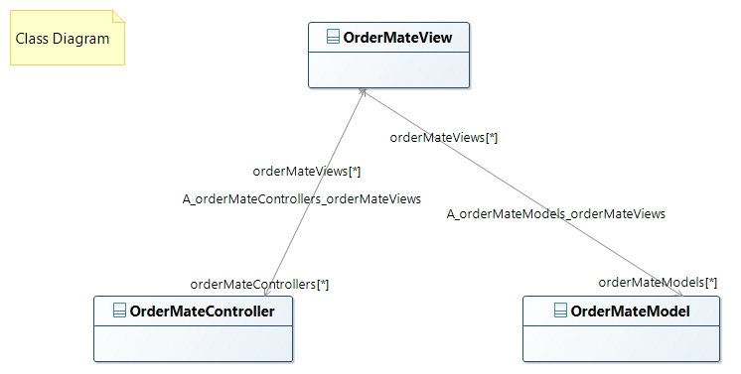

## Design / Testing Evidence

### Start screen

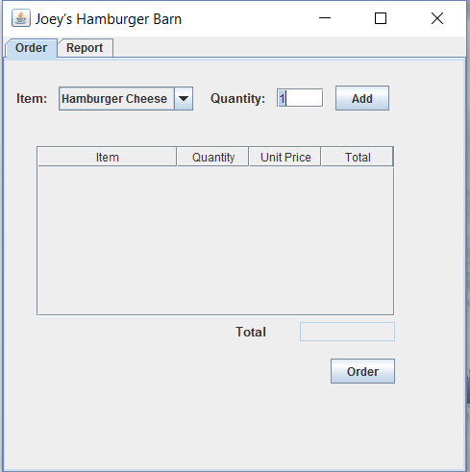

### Order Screen

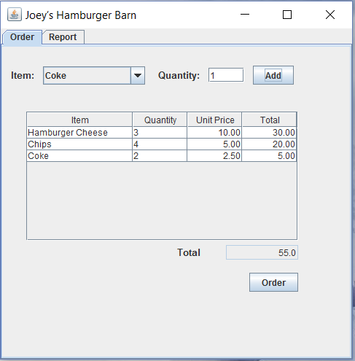

### Order Success Screen

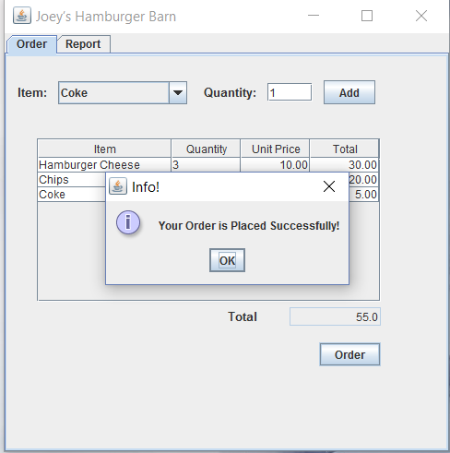

### Report Screen

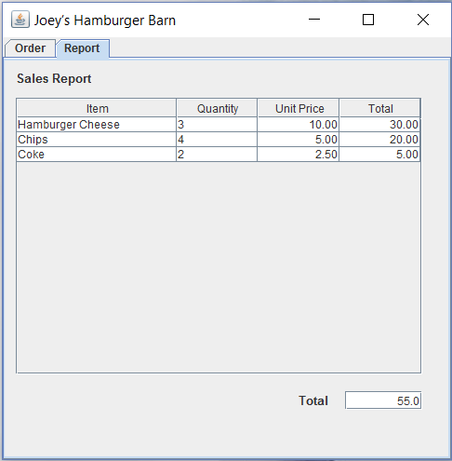

### Order Validation Screen

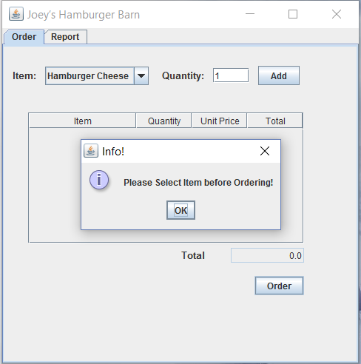

### Quantity Validation Screen

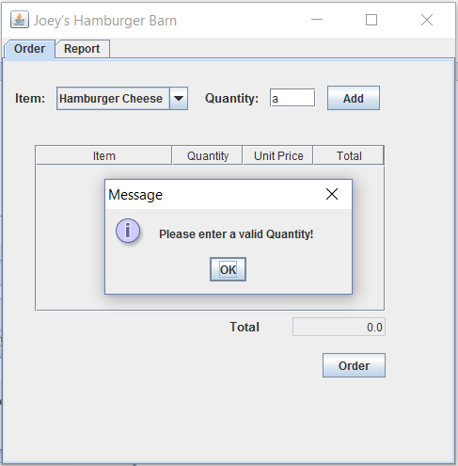

# Possible Improvements

User interface - could be changed to avoid extra mouse clicks and minimal usage of keys.

Limited Exception handling and documentation are done and this can be more extensive and consistent.